Question 4 -

|  |  |  |  |  |  |  |  |  |  |
| --- | --- | --- | --- | --- | --- | --- | --- | --- | --- |
| p | q | r | -q | (-q ʌ r) | P v (-q ʌ r) | | P v -q | P v r | (p v -q) ʌ (p v r) |
| T | T | F | F | F | T | T | | T | T |
| T | T | F | F | F | T | T | | T | T |
| T | F | T | T | T | T | T | | T | T |
| T | F | F | T | F | T | T | | T | T |
| F | T | T | F | F | F | F | | T | F |
| F | T | F | F | F | F | F | | F | F |
| F | F | T | T | T | T | T | | T | T |
| F | F | F | T | F | F | T | | F | F |

The columns of (p v -q) ʌ (p v r) and P v (-q ʌ r) are the same so they are logically equal.

Question 6 –

a.)

|  |  |  |  |  |
| --- | --- | --- | --- | --- |
|  | **00** | **01** | **11** | **10** |
| **00** | 0 | 1 | 0 | 0 |
| **01** | 0 | 1 | 0 |  |
| **11** | 1 | 1 | 1 | 1 |
| **10** | 1 | 1 | 0 | 0 |

b.) xy + xz’ + z’w

Question 11 –

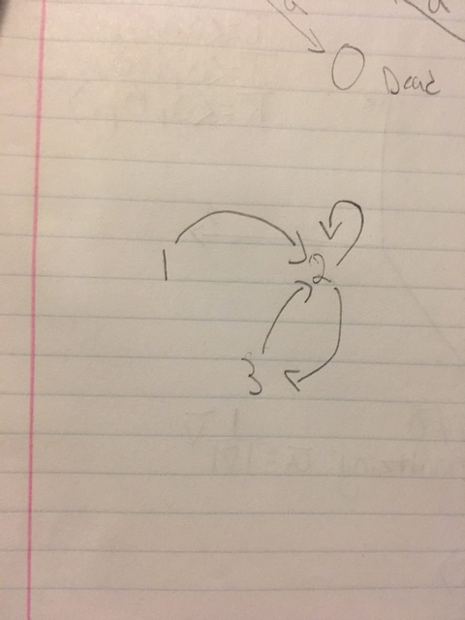

Question 14 –

